Project Name: Find a Pump
Sprint Duration: February 16 – March 22, 2026
Sprint Goals: Implement automated unit testing, address customer feedback
Team Name: Gas Guzzlers
Team Members:
Eric Parral, Nathan Carlson, Kyler Cressall, and Thomas Ross
Prepared by: Eric Parral (Team Lead)
Date Submitted: March 22, 2026

Project Description
Overview and Justification
Find a Pump is a web-based application that strives to help users find the gas station with the cheapest gas near them in Utah County. To help users find a pump that fits their needs, they will be able to filter the results by type of gas (diesel or regular), quality, or even find an EV charger. Users will be able to add in any discounts they receive at specific gas stations to be factored in automatically for them. They will also be able to modify the search area, which will allow them to choose how far they are willing to go for the cheapest gas.
Find a Pump aims to alleviate the pain points of constantly fluctuating gas prices and the current inflation problem by providing users with the latest price information available. This will take the stress out of spending too much money on gas and remove the uncertainty of what the price will be. Utah County is full of college-aged adults who typically have tight budgets and do not have the ability to spend frivolously. Providing them with the cheapest gas options will allow them to enjoy their time and use their money where it matters more fully.
Tech Stack and Measuring Success
The application will integrate Google Maps APIs to provide accurate geolocation and redirect Google Maps to get turn-by-turn directions. A responsive frontend with React will display station distance and current fuel or charging prices. The backend, powered by Node.js with Express, will manage API requests, data aggregation, and communication with external APIs. A local SQLite database will store station metadata, user preferences, and cached results to improve performance. Then for the data processing the application will use JavaScript for the caching and aggregation. Together, this tech stack creates a scalable, intuitive, and reliable application that enhances everyday travel planning.
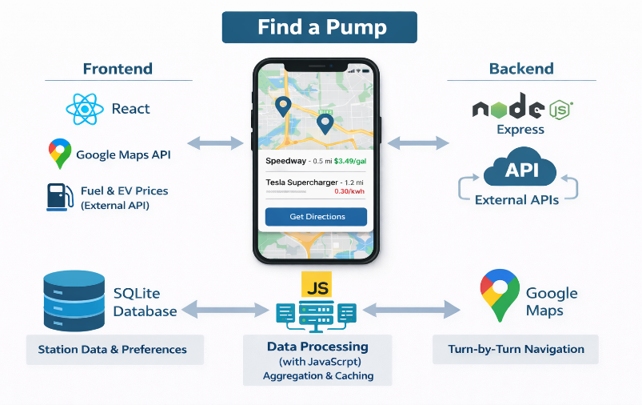
The application is complete once it has met its core functionality goals, reliably retrieving and displaying nearby stations with accurate distance and pricing information. Verifying that the Google Maps redirection works consistently, ensuring seamless navigation for users. From a UI/UX perspective, the interface is clean, responsive, and intuitive, while map interactions such as zooming, panning, and marker selection feel natural. If launched, the shipped version will demonstrate powerful performance, with average API response times under five hundred milliseconds and map and station data loading within two seconds. The user engagement metrics should indicate healthy adoption, reflected in steady daily active users and frequent station lookups per session. Lastly, in terms of reliability, the application maintains 99% uptime over a 7-day period, with API error rates kept below 5%.
API Research
To power our app, it will need live, accurate price data for the different fuel types at gas stations across Utah County. The best way to do this is to use an existing API, which hosts this live data already. One example of an API the application could use is like the one hosted at “ww.oilpriceapi.com,” which can give the real-time prices of fuel at each station filtered by latitude and longitude coordinates with a radius around it. This data will include the prices of the fuel at each station for us to use to display and sort.
To get accurate live data of these prices, when the user opens the app, it will get data from the API. That can store it in the app database to display prices on the map. If a user launches the app again offline or if the API is down, it will use the existing prices in the database to continue to display information. Storing the data from the API in our own database will limit the number of times the API is called, as well as give us more flexibility for querying and displaying the data.
Google Maps API is what will power the geospatial mapping portion of the application. It allows us to use JavaScript to create a live map pulling from Google Maps and then be able to add many pins/markers on the map as needed. This streamlines the process, so all that will need to be done to implement it is to create an API in our backend to query each of the station’s coordinates and prices, then iterate through them, placing them on the map.
Potential Features and Stakeholders
This application is designed to help consumers in Utah County quickly locate nearby gas stations and compare fuel prices in their area. Using the user’s current location, the system will display gas stations on an interactive map or in a list-based view, allowing users to easily identify both the closest and the cheapest options available. Key features include location-based search, fuel price displays for multiple fuel types, distance indicators showing how far each station is from the user, and sorting or filtering options that allow users to prioritize proximity or cost. These features are intended to save users time, reduce fuel expenses, and simplify the decision-making process when choosing where to refuel.
The primary stakeholders of this system are drivers in Utah County who directly benefit from easy access to nearby gas station locations and fuel price comparisons. Secondary stakeholders include gas station owners, who may experience increased visibility and customer traffic when their stations appear competitive options within the application, as well as third-party API and data providers that supply the location and pricing information used by the system. Indirect stakeholders include members of the local community, who may benefit from reduced unnecessary driving, and the development team. Those who are responsible for ensuring the system remain dependable, accurate, and user-friendly.
Meeting Logs: Can Be found within the Zip file
We meet Every Tuesday, Thursday, and Saturday. As well as during the class on Wednesday. Where the meeting time is anywhere from 7:00 P.M or 8:00 P.M on the days that aren’t in the classroom.
Contribution Form
Team Name  Gas Guzzlers | Sprint # | Date | Team Score
Name |  | Contribution (%) | Signature | Individual
Eric Parral |  | 100% | Eric Parral | 100
Nathan Carlson |  | 100% | Nathan Carlson | 100
Kyler Cressall |  | 100% | Kyler Cressall | 100
Thomas Ross |  | 100% | Thomas Ross | 100

Backlogs and Sprints
Sprint # | Assigned Date | Backlogs | Description | Assigned | Finish Date
Sprint 1 | 2/15/26 | 1. API | Get an API key to access gas prices. | To Everyone | TBD
 |  | 2. Data | Get more data to test the API. As well as set up database | Kyler/Thomas | 2/14/26
 |  | 3. Pin | Get it to accurately place a pin on the map. | Eric | 2/10/26
 |  | 4. Env/key | Get access to the map key and have it secured by everyone. | Nathan | 2/4/26

Software Requirements Specifications

1. Functional Requirements

1.1 Core Display
- FR-1: The system shall detect the user's current geographic location automatically or allow manual location input.
- FR-2: The system shall display gas stations within a selected radius on an interactive map.
- FR-3: The system shall represent each gas station using map markers containing station information.
- FR-4: The system shall display all available fuel types and their current prices (regular, mid-grade, premium, diesel) for each station.
- FR-5: The system shall display EV charging station availability when the user enables the EV option.
- FR-6: The system shall allow users to select a specific station to view detailed information including its address, fuel prices, and a link to open directions in Google Maps.

1.2 Search and Filtering
- FR-7: The system shall allow users to view nearby stations as a list in addition to the map view.
- FR-8: The system shall allow users to filter displayed stations by distance.
- FR-9: The system shall allow users to filter displayed stations by fuel price.
- FR-10: The system shall allow users to set a preferred fuel type, which will be displayed prominently on both the map and list views.
- FR-11: The system shall allow users to input personal discount programs tied to specific fuel stations.
- FR-12: The system shall automatically apply saved discounts to the displayed pricing results.
- FR-13: The system shall allow users to modify or remove previously entered discount programs.

1.3 Data Handling
- FR-14: The system shall cache the latest retrieved fuel price data in a local database.
- FR-15: The system shall display cached data when the fuel pricing API is unavailable, or the user is offline.
- FR-16: The system shall automatically refresh cached data when an active internet connection is available.
- FR-17: The system shall display timestamps indicating when the pricing data was last updated.

1.4 Error Handling
- FR-18: The system shall notify users when their location cannot be determined.
- FR-19: The system shall notify users when no stations match their search or filter criteria.
- FR-20: The system shall display an appropriate error message if an external API request fails.
- FR-21: The system shall display previously cached data when live data retrieval fails.

2. Non-Functional Requirements

2.1 Performance
- NFR-1: The system shall provide API responses within 500 milliseconds on average.
- NFR-2: The system shall load the map and station data within 2 seconds.
- NFR-3: The system shall update search and filter results within 1 second.
- NFR-4: The system should support at least 500 concurrent users.
- NFR-5: The system shall retrieve cached data within 200 milliseconds.

2.2 Reliability and Availability
- NFR-6: The system shall maintain at least 99% uptime over a 7-day period.
- NFR-7: The system shall automatically recover from unexpected crashes.
- NFR-8: The system shall use cached data to provide fallback functionality during downtime.
- NFR-9: The system shall synchronize data automatically after downtime.
- NFR-10: The system shall handle unavailable external APIs gracefully without crashing.

2.3 Usability and User Experience
- NFR-11: The system shall provide an intuitive, user-friendly interface.
- NFR-12: Users shall be able to access all core features within three clicks.
- NFR-13: The interface shall be fully responsive across desktop and mobile devices.
- NFR-14: The system shall provide clear visual indicators for fuel stations.
- NFR-15: The system shall display loading indicators while fetching data.
- NFR-16: Error messages shall be user-friendly and include actionable suggestions.

2.4 Scalability
- NFR-17: The system shall support geographic expansion to new regions.
- NFR-18: The backend architecture shall support horizontal scaling.
- NFR-19: The database design shall efficiently handle large datasets.
- NFR-20: Sensitive configuration values shall not be hardcoded in source code.

2.5 Security
- NFR-21: The system shall securely store all API keys and access credentials.
- NFR-22: The system shall validate and sanitize all user input.
- NFR-23: The system shall implement rate limits to prevent abuse.

2.6 Maintainability
- NFR-24: The system shall follow modular design principles.
- NFR-25: The system shall include comprehensive technical documentation.
- NFR-26: The system shall support automated unit and integration testing.
- NFR-27: Version control shall be maintained for all source code.
- NFR-28: The codebase shall follow consistent naming and coding standards.

2.7 Portability and Compatibility
- NFR-29: The system shall operate correctly on all major web browsers.
- NFR-30: The system shall support multiple operating systems.
- NFR-31: The interface shall adapt to various screen sizes.
- NFR-32: The system shall not rely on browser-specific plugins.

2.8 Data Accuracy and Integrity
- NFR-33: The system shall validate all data received from external APIs.
- NFR-34: All stored data shall include timestamps.
- NFR-35: The system shall prevent duplicate records in the database.
- NFR-36: Cached data shall be updated regularly.
- NFR-37: The system shall clearly indicate when displayed data may be outdated.

2.9 Accessibility
- NFR-38: The system shall comply with WCAG 2.1 accessibility standards.
- NFR-39: The system shall support full keyboard navigation.
- NFR-40: The system shall be compatible with screen readers.
- NFR-41: The system shall provide a high-contrast display mode.
- NFR-42: All interactive elements shall include descriptive labels or ARIA attributes.

2.10 Logging and Monitoring
- NFR-43: The system shall log all system errors with severity levels and timestamps.
- NFR-44: The system shall monitor and record API usage.
- NFR-45: Performance metrics shall be recorded continuously.
- NFR-46: Administrators shall receive automated alerts for critical failures.

2.11 Backup and Recovery
- NFR-47: The database shall be backed up daily.
- NFR-48: Backups shall be verified periodically.
- NFR-49: The system shall support full data restoration from backups.
- NFR-50: Backup data shall be stored securely.

2.12 Legal and Compliance
- NFR-51: The system shall comply with Google Maps' API usage policies.
- NFR-52: The system shall comply with all connected fuel data API licensing agreements.
- NFR-53: The system shall protect user privacy according to applicable data protection laws.
- NFR-54: The system shall provide a publicly accessible privacy policy.
- NFR-55: The system shall not store personally identifiable information without explicit user consent.

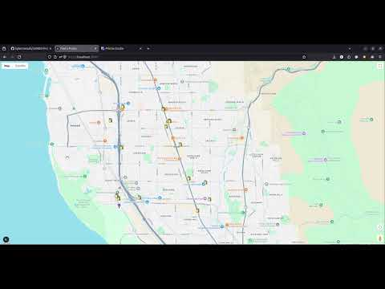
Demo Video/Prototype
To access the code, please go to this GitHub: https://github.com/kylercressall/cs4400-findapump

Design
Architecture Diagram
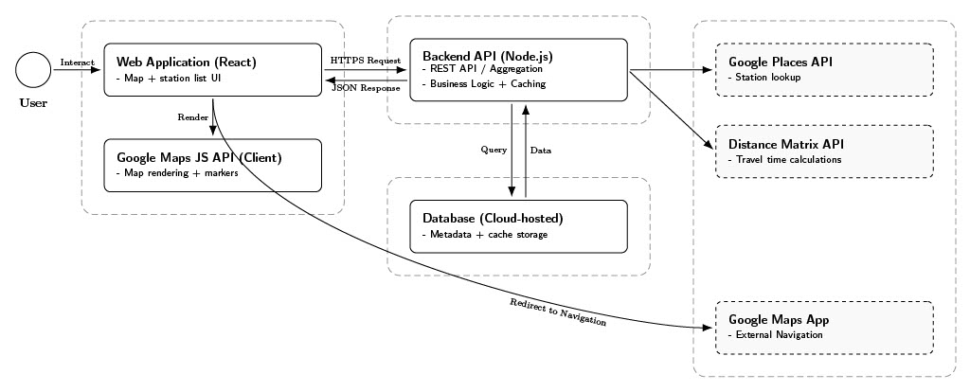

Table 1: https://github.com/kylercressall/cs4400-findapump/blob/main/documentation/UML/Architecture_diagram.pdf
This diagram illustrates the three-tier architecture of the Find A Pump system. The React frontend communicates with the Node.js Express backend via RESTful APIs. The backend integrates with external services including the Fuel Pricing API and Google Maps API. A SQLite database stores caught pricing data and user preferences. This design ensures separation of concerns and supports scalability.
Entity Relationship Diagram
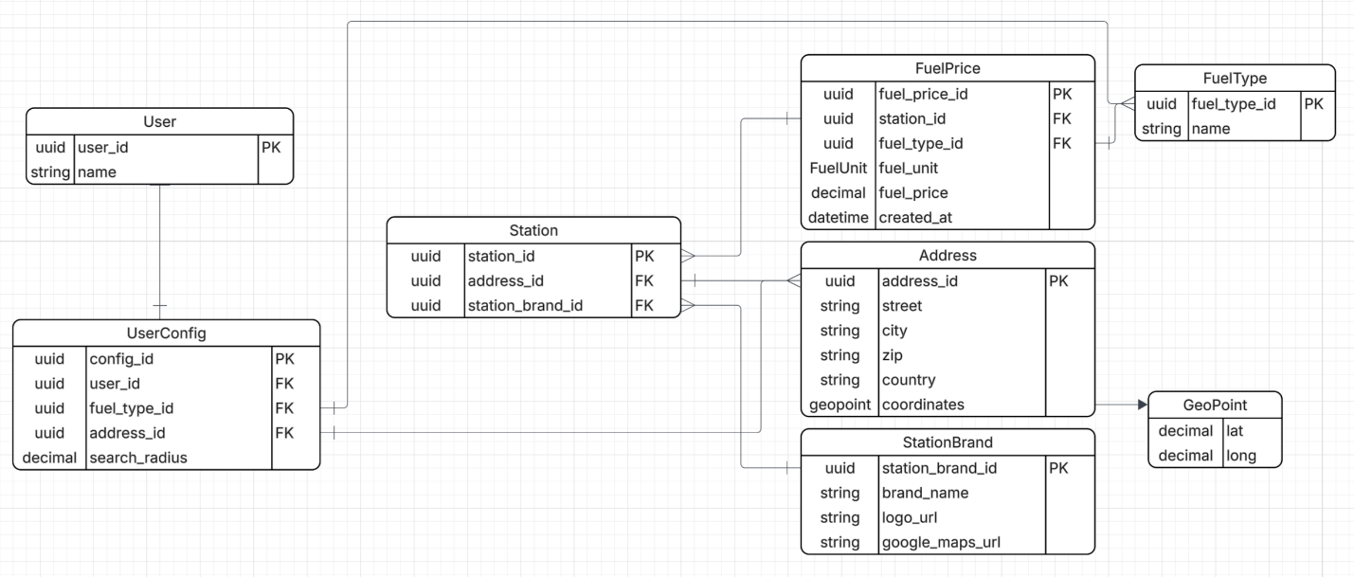
Table 2: https://github.com/kylercressall/cs4400-findapump/blob/main/documentation/UML/entity-relationship-diagram.png
The ER diagram defines relationships between Stations, Fuel Types, Prices, and User Preferences. Primary keys and foreign key constraints ensure data integrity. Timestamp fields are included to support caching validation.
Use Case Diagram
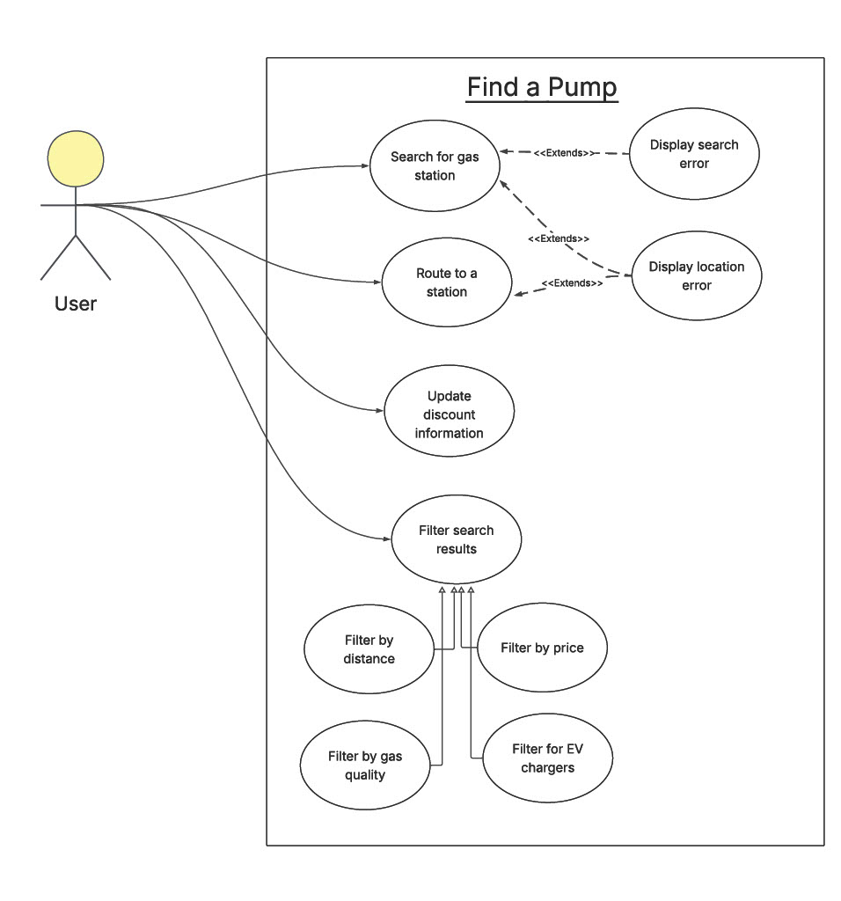
Table 3: https://github.com/kylercressall/cs4400-findapump/blob/main/documentation/UML/Find%20a%20Pump%20--%20Use%20Case%20Diagram.pdf
The use case diagram outlines 12 primary user interactions, including searching for stations, applying filters, entering discounts, viewing station details, and navigating via Google Maps. All use cases are maintained at the same abstraction level to ensure balanced granularity.
Class Diagram

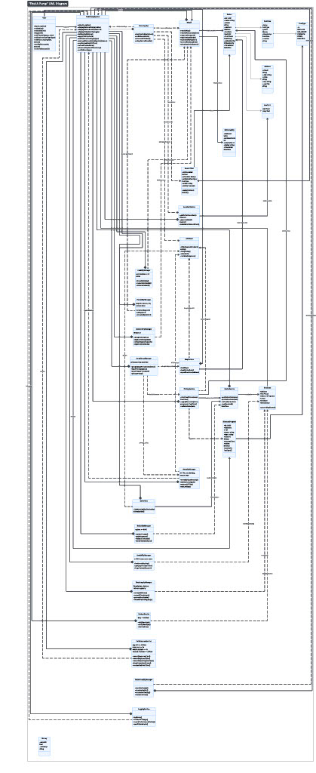
Table 4 https://github.com/kylercressall/cs4400-findapump/blob/main/documentation/UML/Rough%20Uml-Find%20A%20Pump.pdf
The class diagram enforces high cohesion and loose coupling. Each class contains no more than five instance variables and ten methods. Major classes include:
- Station
- FuelPrice
- DiscountManager
- MapService
- APIService
- CacheManager

Customer Feedback
During Sprint 2, feedback focused primarily on improving the clarity, structure, and completeness of the project documentation, as well as strengthening the testing strategy.

1. Documentation Clarity and Structure
- Feedback:
The report required improved clarity, organization, and stronger connections between sections.
- Action Taken:
  - Added title page.
  - Numbered functional and non-functional requirements.
  - Redesigned class diagram to improve readability.
  - Broke down customer feedback into structured entries.
  - Explicitly linked feedback to functional requirements.
  - Added meeting logs and contribution forms to Appendices A and B, respectively.
  - Standardized naming conventions by ensuring full names are used consistently throughout the documentation.
  - Fixed all incorrect dates for backlog assignment and completion dates.
- Impact:
Improved maintainability and alignment with software engineering documentation standards.

2. Testing Coverage and Implementation
- Feedback:
Greater emphasis was needed on implementing and documenting testing for the system.
- Action Taken:
  - Expanded unit and integration test coverage for both frontend components and backend APIs.
  - Improved test plan to include more detailed scenarios and coverage.
  - Ensured tests align with system requirements.
  - Ensured all currently implemented functional and non-functional requirements have associated test cases.
- Impact:
Increased system reliability and better validation of core features. This also ensures traceability between functional and non-functional requirements and their corresponding test cases.

3. Carryover Feature Feedback (from Sprint 1)
The following feature-related feedback from Sprint 1 continues to guide development and will be incorporated into future iterations.

3.1. EV Charger Integration
- Feedback:
The system should support displaying electric vehicle (EV) charging stations in addition to gas stations.
- Interpretation:
Users may drive electric vehicles and require access to charging locations, expanding the system beyond traditional fuel types.
- Action / Requirement:
  - Add support for EV charging station data in the backend.
  - Update map UI to display EV charging locations.
  - Introduce filtering options for fuel type (Gas vs EV).
- Related Requirement:
  - FR-5: The system shall display EV charging station availability when the user enables the EV option.

3.2. Price Range Filtering
- Feedback:
Users should be able to filter out gas stations that fall outside a selected price range.
- Interpretation:
Users are primarily interested in affordable options and need a way to quickly exclude expensive stations.
- Action / Requirement:
  - Implement a price range filter (min/max).
  - Update frontend UI with slider or input fields.
  - Modify backend queries to return only stations within range.
- Related Requirement:
  - FR-9: The system shall allow users to filter displayed stations by fuel price

Testing/QA
Test Plan
Introduction:
The purpose of this test plan is to ensure the Find a Pump meets its functional and non-functional requirements and behaves correctly under expected and edge-case conditions.
Scope:
Functional requirements include:
- Location detections
- Stations displayed on the map
- Station details
- Search filtering
- Preferred fuel type
- Discounts
- Caching/offline mode
- Timestamps
- Refresh behavior
- Error handling for:
  - No results
  - API failures
  - Cached fallback
- API data validated
- Timestamps present
- Routing opens correctly.
Non-functional requirements include:
- Performance
- Reliability
- Usability
- Scalability
- Security
- Maintainability
- Portability
- Accuracy
- Accessibility
- Logging/monitoring
- Backup/recovery
Test Approach:
- Unit tests
  - Validation
  - Discount math
  - Filtering/sorting logic
  - Catching behavior
- Integration tests
  - Frontend
  - Backend
  - Database cache
- c. System tests
  - Real user flow across map/list
  - Filters
  - Station details
  - Offline mode
- Non-functional tests
  - Performance timings
  - Accessibility checks
  - Basic security checks
  - Resiliency
Test Data:
A seeded station dataset with:
- Multiple stations, fuel types, prices, and varied distances
- Some missing or invalid API fields for validation tests
- Discount programs matching specific stations
- Cached snapshot with timestamps
Test Environment:
The testing environments will be finalized by the end of sprint 2. It will most likely include multiple browser types, device types, online and offline modes, and location services allowed and blocked.
Test Cases:
Test cases will be finalized by the end of sprint 2. They will cover the expected scope of the testing plan with pass/fail information included.
Pass/Fail Criteria:
Functional: 100% of functional test cases must pass.
Non-functional: Must meet defined thresholds
Any crash on common user flow is a fail.
Schedule:
This testing plan will be finalized by the end of sprint 2. The unit testing and integration testing will be performed in sprint 3. System testing and non-functional testing will be carried out in sprint number 4.
Quality Assurance Metrics
Design metric:
The design metric chosen for Find a Pump is high cohesion. This will be achieved by clearly dividing responsibilities and ensuring that each module has a single, well-defined purpose. High cohesion improves maintainability, makes the system easier to understand, and helps isolate defects, which in turn facilitates faster debugging and more reliable enhancements.
Testing metric:
The chosen testing metric for Find a Pump is testing pass rate. The project will track the percentage of automated and manual tests that are passed during each test cycle. The goal is to maintain a 100% pass rate before release to ensure that core functionality remains stable and that regressions are caught early.
QA metric:
Find a Pump is committed to maintaining a high defect removal efficiency (DRE) in order to catch as many defects as possible before release. This metric measures the proportion of defects found before deployment compared to those found after release. A high DRE reduces the number of escaped defects and helps ensure a higher quality product for end users.
Process metric:
To ensure that Find a Pump is released in a timely manner, sprint velocity will be monitored and evaluated. Tracking sprint velocity allows the team to measure how much work is completed per sprint, improve planning accuracy, and identify potential slowdowns, while still maintaining a strong focus on quality.
Maintenance metric:
For maintenance, find a Pump will monitor the size of its maintenance backlog and aim to keep it as small as possible. This will be achieved by consistently prioritizing and addressing bugs, technical debt, and post-release issues, helping ensure long-term stability and maintainability of the system.
ReadMe

Find A Pump
A full-stack web application that allows users to locate nearby gas stations and compare fuel prices through an interactive map interface.

Project Overview
Find A Pump is a monorepo-based full-stack application consisting of:
- A Next.js frontend
- A Node.js + Express backend
- A SQLite database managed with Prisma ORM
- Turborepo for running frontend and backend concurrently
The backend follows industry-standard architecture:
Routes → Controllers → Services
This separation ensures:
- Routes define endpoints only
- Controllers handle validation and HTTP responses
- Services contain business logic and database operations

Repository Structure
Find-A-Pump-Project/
│
├── documentation/
├── find-a-pump-code/
│ ├── apps/
│ │ ├── frontend/
│ │ └── backend/
│ ├── prisma/
│ ├── package.json
│ ├── turbo.json
│ └── pnpm-workspace.yaml

Prerequisites
- Node.js (v20+)
- pnpm
Install pnpm if needed:
npm install -g pnpm
Verify installations:
node -v
pnpm -v

Installation & Setup

1. Clone the Repository
git clone https://github.com/kylercressall/cs4400-findapump.git
cd cs4400-findapump/find-a-pump-code

2. Install Dependencies
pnpm install

3. Set Up Environment Variables
Create the following files:
apps/backend/.env
DATABASE_URL="file:./dev.db"
PORT=4000
apps/frontend/.env.local
NEXT_PUBLIC_GOOGLE_MAPS_API_KEY=your_google_maps_api_key_here
Note: A valid Google Maps JavaScript API key is required for the map to render properly.

4. Initialize Database (First Time Only)
cd apps/backend
pnpm prisma generate
pnpm prisma db push
pnpm prisma db seed
cd ../..

Running the Application
From the find-a-pump-code directory:
pnpm run dev
This starts both applications:
- Frontend: http://localhost:3000
- Backend: http://localhost:4000
Restart the development server after modifying environment variables.

Viewing the Database (Optional)
To inspect the database:
cd apps/backend
pnpm prisma studio
Then visit:
http://localhost:5555

Backend Architecture
The backend uses structured separation:
- routes/ – Defines API endpoints
- controllers/ – Handles validation and HTTP responses
- services/ – Contains business logic and database operations
This structure improves maintainability, scalability, and clarity.

